

UNIVERSITY TECHNOLOGY MALAYSIA

LAB EXERCISE 2
SECJ1013-03
(PROGRAMMING TECHNIQUE I)

NO | NAME | MATRIC NO
1 | IMAN ABADI BIN MOHD NIZWAN | A23CS0084

Code :
#include <iostream>
#include <iomanip>
#include <cmath>
using namespace std;

//Prototypes
void matrices();
double euclidean(int, int, int, int);

// Global Variables
int x_1 = 1, y_1 = 3, x_2 = 2, y_2 = 6, x_3 = 5, y_3 = 4;

int main()
{
// Constructing the table
cout << "\n";
matrices();
cout << "\n";

// Distance AB
double euclidean (int x_1, int x_2, int y_1, int y_2);
cout << "\t" << "AB = " << euclidean(x_1, x_2, y_1, y_2) << "\n";

// Distance AC
double euclidean (int x_1, int x_3, int y_1, int y_3);
cout << "\t" << "AC = " << euclidean(x_1, x_3, y_1, y_3) << "\n";

// Distance BC
double euclidean (int x_2, int x_3, int y_2, int y_3);
cout << "\t" << "BC = " << euclidean(x_2, x_3, y_2, y_3) << "\n";

return 0;
}

void matrices()
{
int x [3] = {1, 2, 5};
int y [3] = {3, 6, 4};
char coordinate [3][3] = {"A", "B", "C"};

for (int count = 0; count < 3; count++)
{
if (count == 0)
{
cout << "\t" << coordinate[count] << "(" << x[count] << "," << y[count] << ")";
}
else if (count == 2 )
{
cout << ", and " << coordinate[count] << "(" << x[count] << "," << y[count] << ")";
}
else
{
cout << ", " << coordinate[count] << "(" << x[count] << "," << y[count] << ")";
}
}

cout << "\n";
cout << "\n";

cout << "\t" << " " << setw(9) << "x" << setw(9) << "y" << "\n";

for (int count = 0; count < 3; count++)
{
cout << "\t" << coordinate[count] << setw(9) << x[count] << setw(9) << y[count] << "\n";
}

}

double euclidean(int a, int b, int c, int d)
{
// Difference of both x and y
int difference_x = a - b;
int difference_y = c - d;

// The square of the difference of x and y
int xpower2 = pow(difference_x,2);
int ypower2 = pow(difference_y,2);

// Square root of the sum of squares
double distance = sqrt(xpower2 + ypower2);

return distance;
}
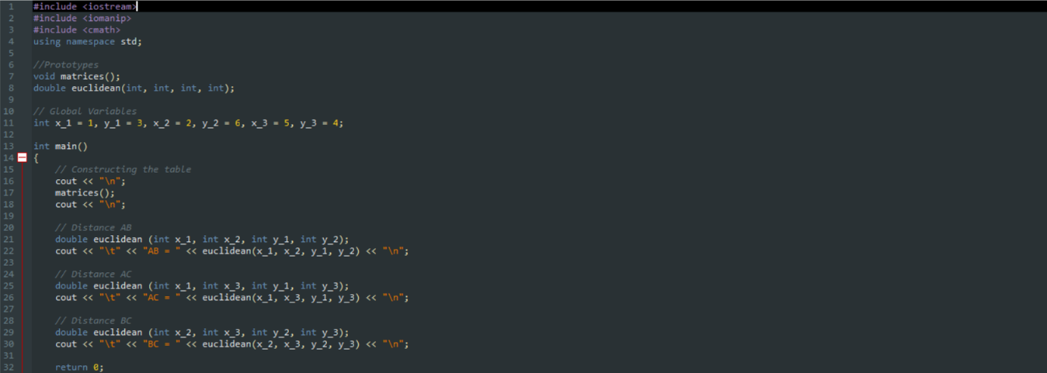
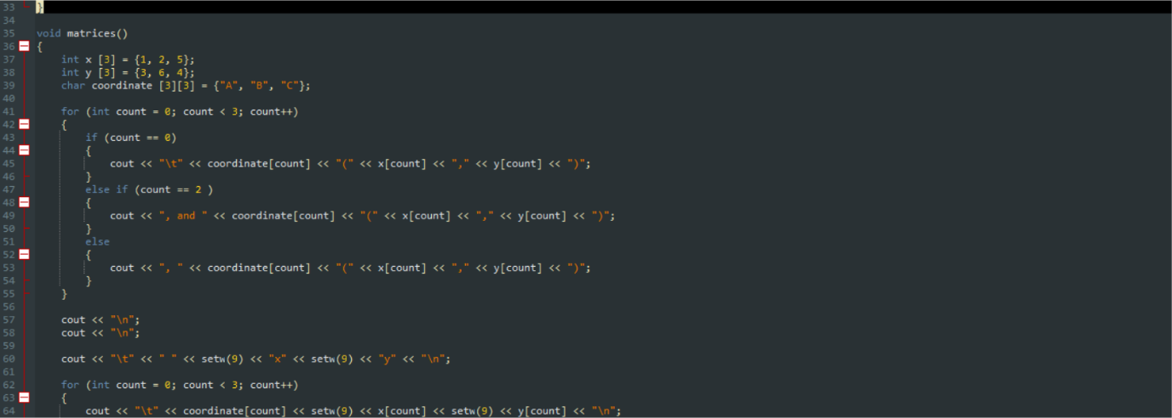
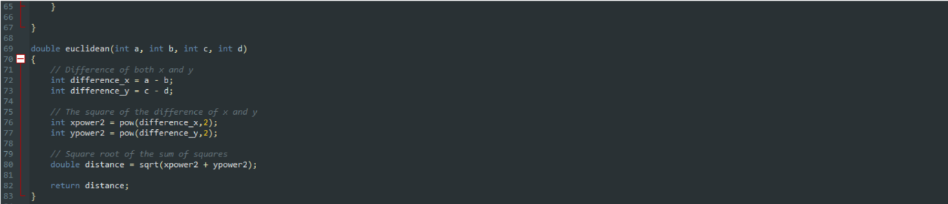
Output:
